**Gordon College Uniform**

**Reservation System**

**Submitted by:**

**Group: Code Us**

**Fatrizha Alejah Boongaling**

**Beverly Karen Bernardino**

**Arshley L. Tan**

**Submitted to:**

**Ms. Mayer Z. Sanchez**

**Instructor**

1. **INTRODUCTION**

Because of the covid-19 face to face classes is not allowed and the students of Gordon College are using remote learning using internet and devices to access and to teach students. So we the group of Code Us 2nd year College of Bachelor of Science in Information Technology in Gordon College come up with the idea of making an website that will allows students to reserve uniforms so they don’t need to fall in a long line when the school starts and also it can lessen time and effort to reserve uniform because you can reserve yours wherever you are instead of going to school get struggle waiting too long to reserve yours. As a IT students we make a way to solve the problem by creating an website or application so in this idea will help students to reserve their uniforms through our Gordon College Uniform Reservation Website.

1. **BACKGROUND OF THE PROJECT**

This Gordon College Uniform Reservation Website is created to reserve uniforms in Gordon College only for GC students. This reservation site will minimize the time of students because even if you are anywhere you can reserve and get the uniform when it release instead of going to school and falling in long line for reservation. Only students of Gordon College can access and login in Gordon College Uniform Reservation. The login system use student id and given password that can be change later by the student when they logged in.

1. **FLOWCHART**

Login page

Login

is the account login successfully?

Display alert message.

No

Yes

Reserve

Uniform page

is the reserve success?

Inserting into database.

uniform_reservation table.

No

Message: failed! try again.

Yes

Is user click logout?

Message: Reserve successfully!!

Return to uniform page

Yes

No

1. **DATA FLOW DIAGRAM (DFD)**

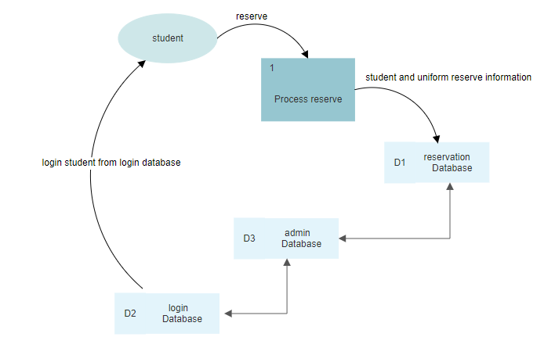

1. **ERD**

|  |
| --- |
| reservation |
| reserveNo |
| studentID |
| Course |
| Fullname |
| uniform_type |
| uniform_size |
| uniform_qty |

|  |
| --- |
| admin |
| adminID |
| username |
| password |



|  |
| --- |
| login |
| ID |
| studentID |
| department |
| Couse |
| Year |
| Fullname |
| password |



1. **BMC**

* **DECRIPTION**

Gordon College Uniform Reservation is a private website only for students of Gordon College Olongapo City. This allows students to reserve uniform through this website. They can access this site and login their account by their corresponding student ID and given password by the admin which is us the creator of the website. This will minimize the physical contact of student to other students especially right now there are covid-19.

* **CUSTOMER SEGMENTS**

Our target customers are:

- Gordon College Students

- Mass market target

* **VALUE PROPOSITION**

**Gordon College Uniform Reservation**: “*Reserve now. Pay & get later.”*

**Product:** Gordon College Uniform Reservation

**Target Market**: Students of Gordon College.

**Primary Benefit:** Online reservation of uniform, friendly user interface & no need to go to school to reserve you can do it through online.

**What makes it unique?** Gordon College Uniform Reservation is an private website for students of GC. The design and the simple process of reserving uniforms is the uniqueness of this site.

* **CHANNELS**

- Word of mouth

- Social Media Page (GC)

- Poster

* **CUSTOMER RELATIONSHIP**

- User Friendly interface

- Accessible and Reliable

- Assistance

- Feedback

* **REVENUE STREAMS**

- Free access but only for students of GC.

- Can earn profits from making advertisements in social media sites.

* **KEY RESOURCES**

Human Resources -Partnership, uniform supplier, employees and developers.

Financial Resources – for web application needs.

Intellectual Resources – customer databases.

* **KEY ACTIVITIES**

Service – Reservation of uniform.

Problem Solving - – creating solutions for our user encountered problems in the site.

* **KEY PARTNERS**

Gordon College COOP - They are the one who will acquire reservations and Update the announcement through Social Media page if the uniforms are ready to get.

Gordon College Head - The one who will confirm and check all the reserve uniforms through GC Admin Reserve List.

Co-Information Technology partner – group members.

* **COST STRUCTURE**

- Web application development costs

- Advertisement expenses (Poster)

- Server/deployment costs (if deployed)

1. **DIVISION OF LABOR**

Arshley L. Tan (Back-end web developer)

- Created the databases and tables.

- Programmed functions & process of reservation. (PHP, MySQL & HTML)

- Documentation.

Beverly Karen Bernardino (Front-end web developer)

- Created the whole website and system design which is the User Interface (UI) and User Experience (UX). Including the login page of the user (student) and login page of the admin.

(HTML, CSS, JS)

- Documentation.

- Collect & made 100+ for user login data.

Fatrizha Alejah Boongaling (Tester)

- Test the whole website if there is a bug and error. Test all the functionalities and the connection of the website into the database system, and check the codes of the whole website and also the back-end system and database and the one who fixed bugs.

- Collect & made 100+ for user login data.

- Documentation.

1. **UI DEMO**

* Login page (student)

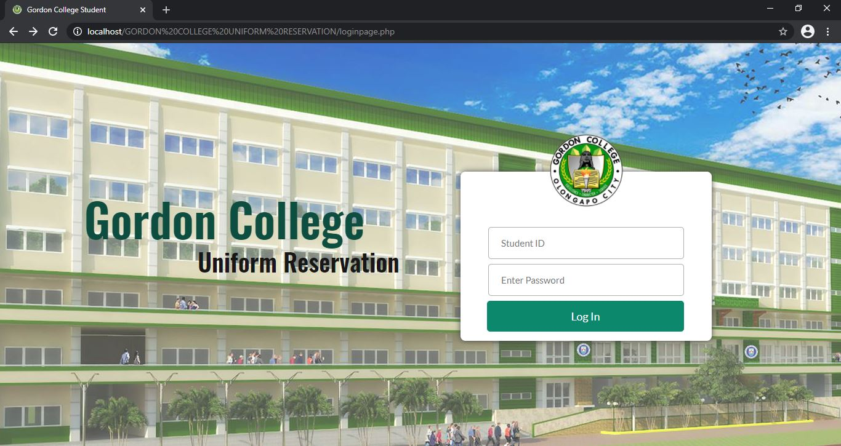

* Login page (admin)

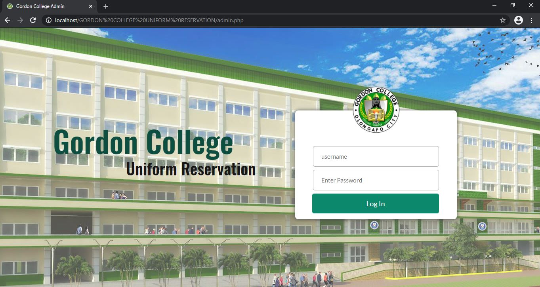

* Uniform page (automatic home page of the website)

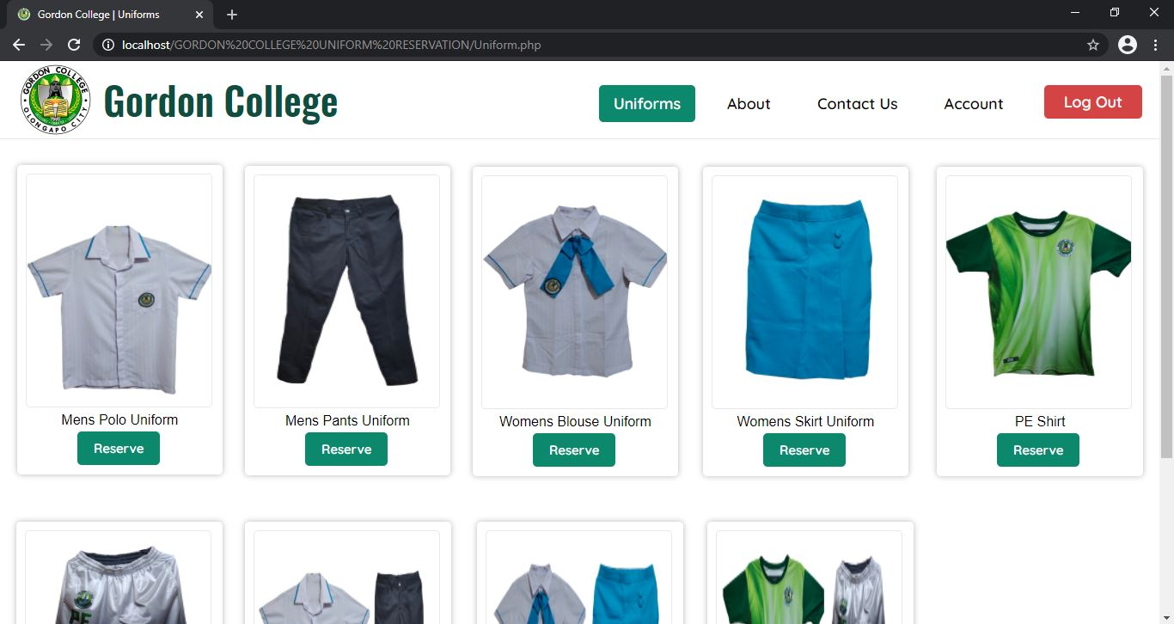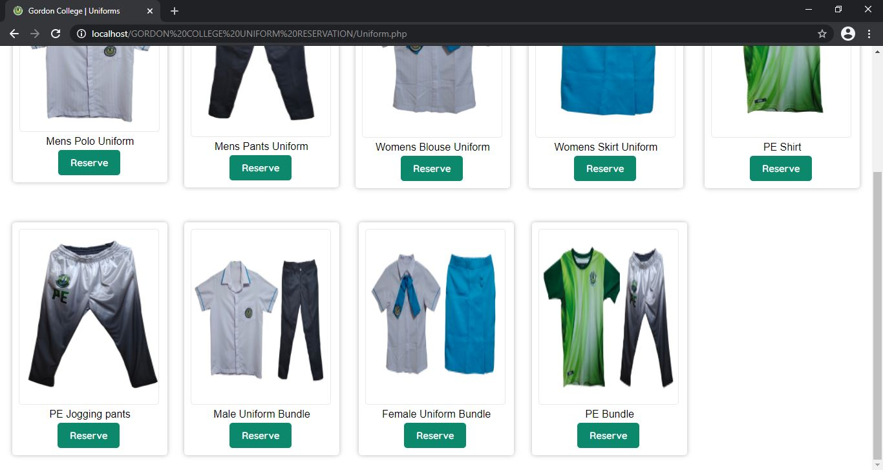

* About page (about the page & creators of the page including responsibilities/tasks)

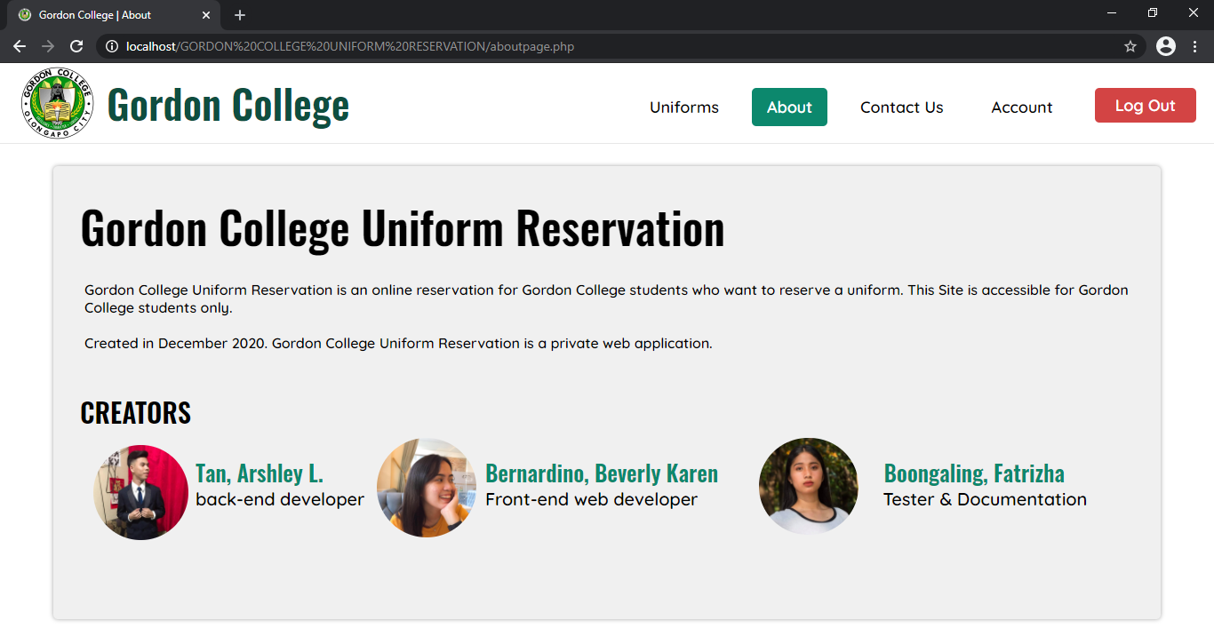

* Contact Us (a section which can student reach the Gordon College to ask questions and other things that is related to this site.)

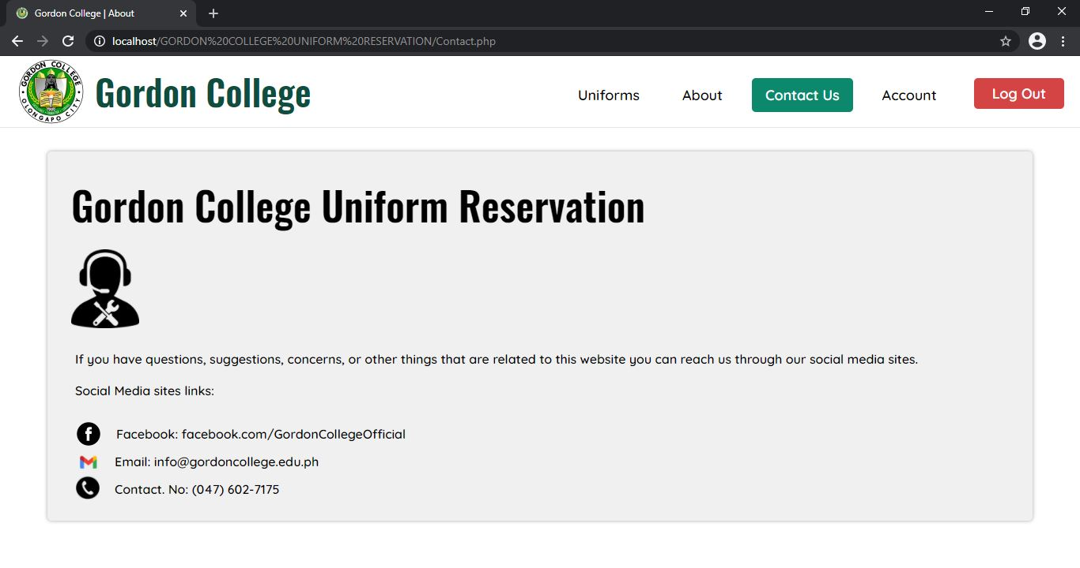

* Account (View Student ID, Full name, Course & Year, And department. Also, you can change your password in this page.)

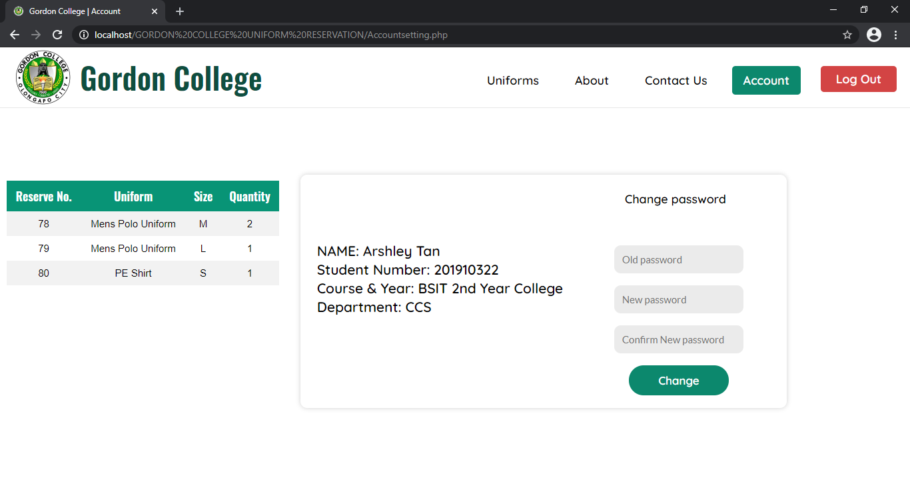

* Admin home page (Reserve List)

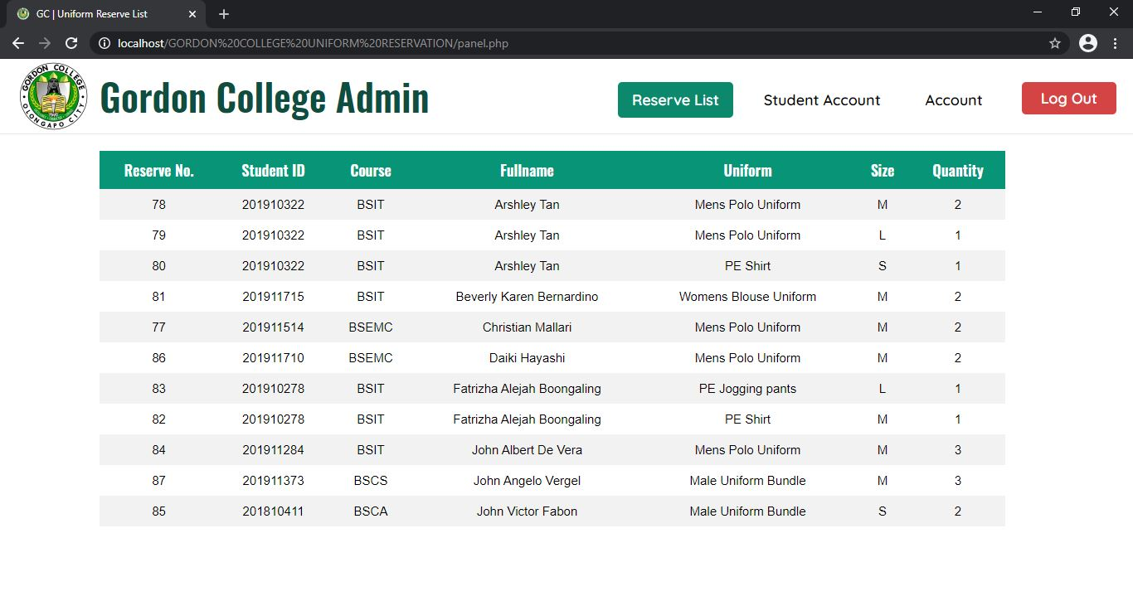

* 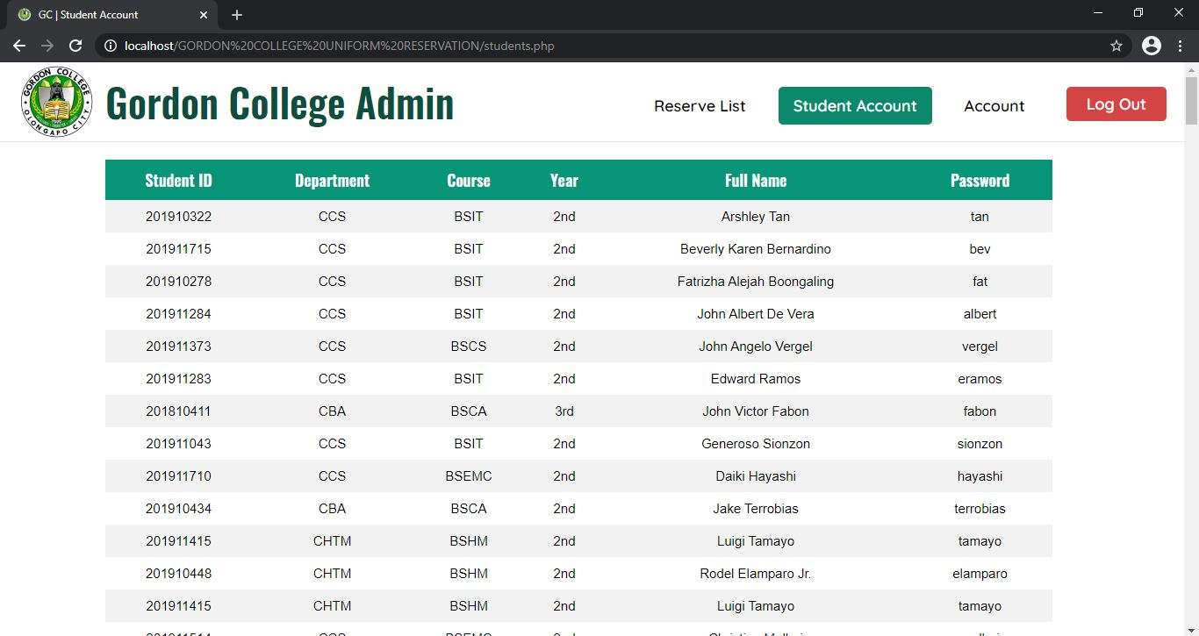Student Account List (with password)
* Admin change password

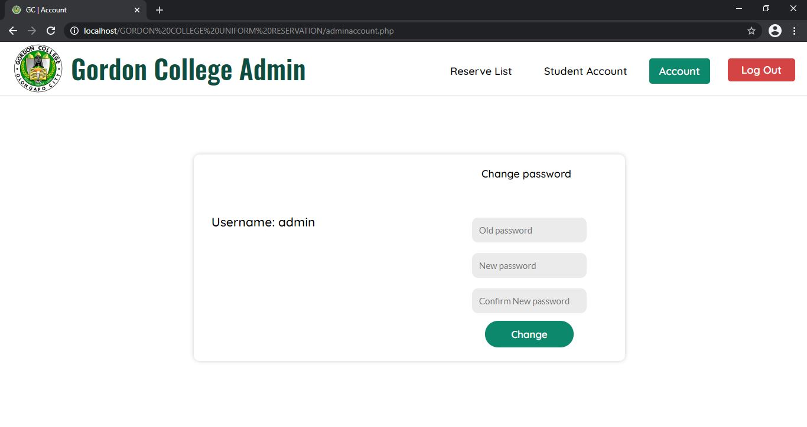

1. **DATABASE DEMO**

* DATABASE & TABLES

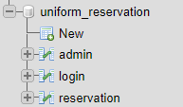

* Admin table



* Login table (student accounts)

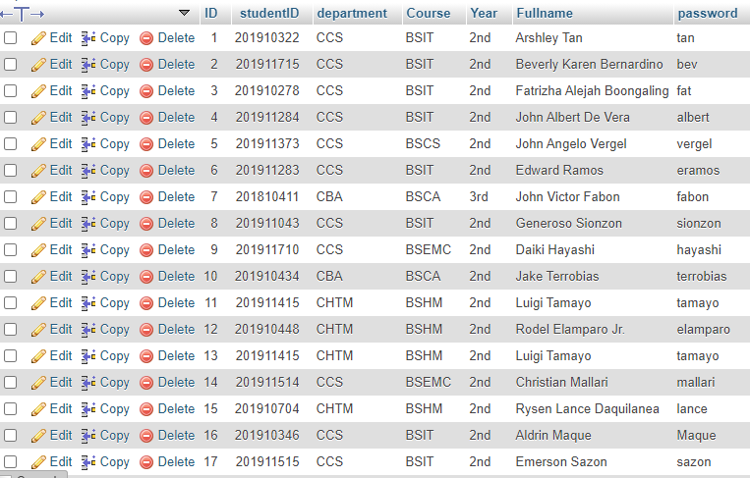

18 – 203 data (more data below but no screenshot because its too long)

* Reservation table

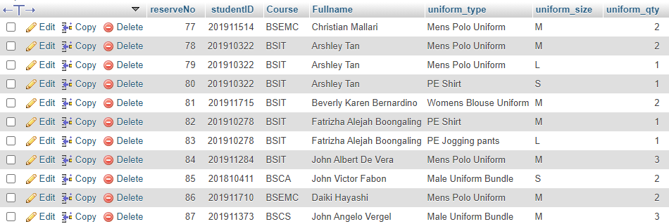

* Reservation List in webpage



* ****Login List in web page (student accounts & information)

1. **CONFLICT ENCOUNTER**

The conflicts we encounter are:

* Connecting php into database but its solved now.
* XAMPP error. It’s an application error where our programmer XAMPP application is no connecting to the server because MySQL is unexpectedly shutdown.
* Process of locating and viewing user’s data in account page. But its solved now.
* The pop-up modal made me cry hard to create but I’ve done it. This modal is for reservation.
* Reservation button process when modals come up with the uniform name, size, and quantity it’s really hard to make it and to debug because it has a lot of errors.
* Positioning of the uniforms in uniform page.
* Login page process. This is the first and for me most difficult part. There is a bug on this were when the user login and prompt the homepage and then the user logout and when she/he press the back button of the browser his/her account will login again without signing in in this case user privacy may view by others instantly when you click browser back button even if the user press logout. I’m glad that this bug is fixed almost 5 days.
* Time management.
* Lack of group discussion and interaction because its hard to make a plan or a project when the only way to communicate to your members is internet and no physical interaction or discussion due to covid-19 and there is no face to face.
* Website design and effects especially the color scheme and the fonts. Picking color scheme and fonts is also difficult because the font and colors should match according to the website is about. So, we decided that the color we use is lightly green/green and put two different font- styles.
* Drop down selection of uniform type in the pop-up modal. This drop-down selection is way to get the selected uniform of the student and pass it to the database of reservation so the admin will know the selected uniform. But this is only a temporary option because its hard to get the uniform name using html and php. In this case you can reserve any other uniform even if you click reserve button in different uniform image. We need to learn client-side script which is the AJAX to fix this bug but from now we don’t have the knowledge about it. But soon it will get fixed once we have the idea of scripts.

1. **SYSTEM SPECIFICATION**

To access smoothly the website and to compile and run the codes of this website the system of computer specifications should be:

**Operating** **System**: Windows 10

**Processor**: Intel Pentium - Intel Core i9 10th gen

**RAM**: at least 4GB RAM.

**Computer Architecture**: X64-bit

For compilation of codes requirements:

**IDE:** Visual studio, Sublime, Visual studio Code, Atom, Notepad++, etc.

**Database Connection:** XAMPP (phpMyAdmin).

**Device Specifications:** 4GB+, Windows 10, Intel Core i3 9th gen

**(**put the folder into [Disk Letter]:\xampp\htdocs\GORDON COLLEGE UNIFORM RESERVATION)

Run XAMPP application > Start Apache & MySQL search in the browser:

Student: <http://localhost/GORDON%20COLLEGE%20UNIFORM%20RESERVATION/loginpage.php>

Admin: <http://localhost/GORDON%20COLLEGE%20UNIFORM%20RESERVATION/admin.php>

1. **CONCLUSION**

As we conclude that this Final project website is useful and efficient enough to gather student’s information and reservation of uniforms. Students data is secured and privacy of their information is secured in the database. Gordon College Uniform Reservation Website is not totally finish, there are some things need to put and need to fix soon when we the programmers and creators of this website broaden our knowledge in different scripts and languages. For us this is a very good start for us making an website that can help students not also students also the schools that might need this type of reservation website to help and make a efficient way for students and school workers.

1. **RECOMMENDATION**

System and devices capabilities is a must in viewing or searching the website. As the creator of this website, we recommend to use minimum device specifications so the users will have a better experience in viewing and reserving uniforms in Gordon College Uniform Reservation Website. As for the purpose of this website this is created only and exclusively for Gordon College students. Only students of GC can access, login in the website. This is mainly focus on the students of GC. This website is private. Updating website codes, functions, bugs may students encounter, minimize process and memory usage will be done by the developer as soon as possible. We recommend that use the given student ID for the login and the given password and students may change their own password once they logged in.